**RESTAURANT CRM**

**Company Information**

This is the foundation of any Salesforce organization. The *Company Information* section stores the official details of the business such as the company name, address, time zone, default currency, and fiscal year.

* **Organization Name**: Defines how the system recognizes your company and how it will appear in system headers, licenses, and reports. For example, *Restaurant CRM Pvt Ltd*.
* **Default Time Zone**: Ensures that all date/time stamps, workflows, and automation rules work according to the company’s working hours. For India, we use (GMT+05:30) India Standard Time.
* **Default Currency**: Determines the default currency for opportunities, reports, and transactions. Businesses that operate in multiple regions can enable **multi-currency**.
* **Fiscal Year**: Critical for reporting revenue and performance. Salesforce supports both **Standard Fiscal Years** (Jan–Dec) and **Custom Fiscal Years** (e.g., Apr–Mar for Indian businesses).

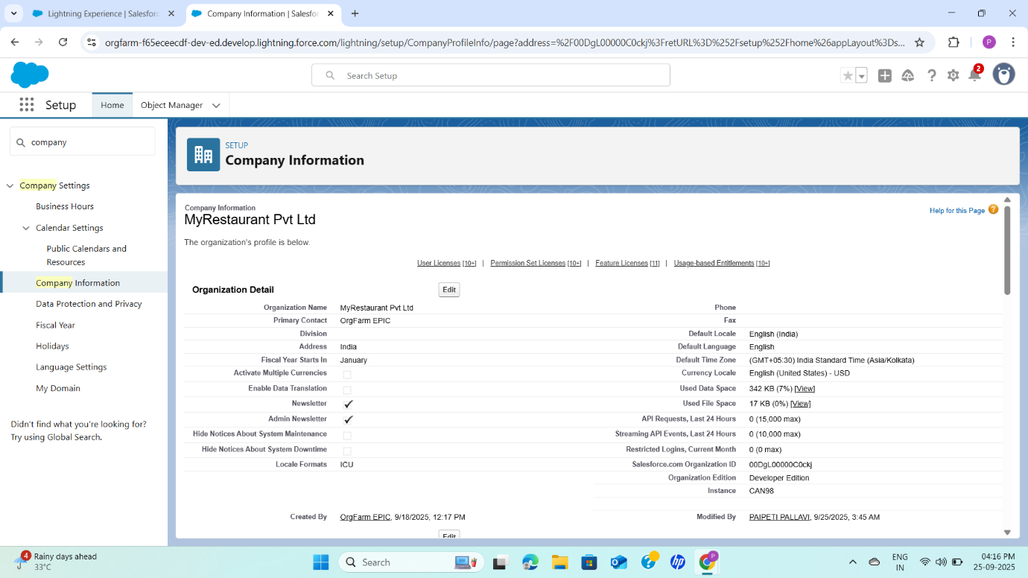

**2. Business Hours**

Defining *Business Hours* in Salesforce is vital because many service-related features, like **case escalations, SLA timers, and workflow triggers**, depend on them.

* Example: The restaurant operates from **11:00 AM to 11:00 PM** every day.
* Marking them as **default** ensures they apply across customer support cases and automation flows unless overridden.
* Having clear business hours helps track SLA commitments more accurately.

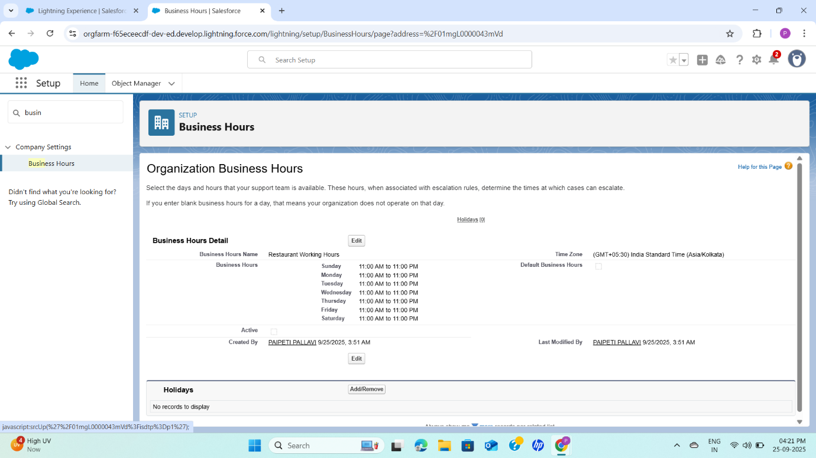

**3. Holidays**

**Holidays allow you to define non-working days in Salesforce. These are linked to business hours to ensure SLA calculations and workflows don’t count those days.**

* **Example: *Diwali – Nov 12, 2025*.**
* **When a holiday is marked, Salesforce automatically pauses SLA timers and escalations on that day.**
* **This ensures accurate reporting and avoids penalizing the support team during holidays.**

## **4. Fiscal Year**

The *Fiscal Year* setup directly affects **reporting, forecasting, and dashboards**.

* **Standard Fiscal Year**: Runs Jan–Dec. Recommended for global organizations unless specified otherwise.
* **Custom Fiscal Year**: Can follow any 12-month pattern (e.g., Apr–Mar for Indian businesses). This is useful for aligning Salesforce reporting with statutory accounting requirements.

Once a fiscal year type is enabled, it affects all company reports, so the decision must be made carefully.

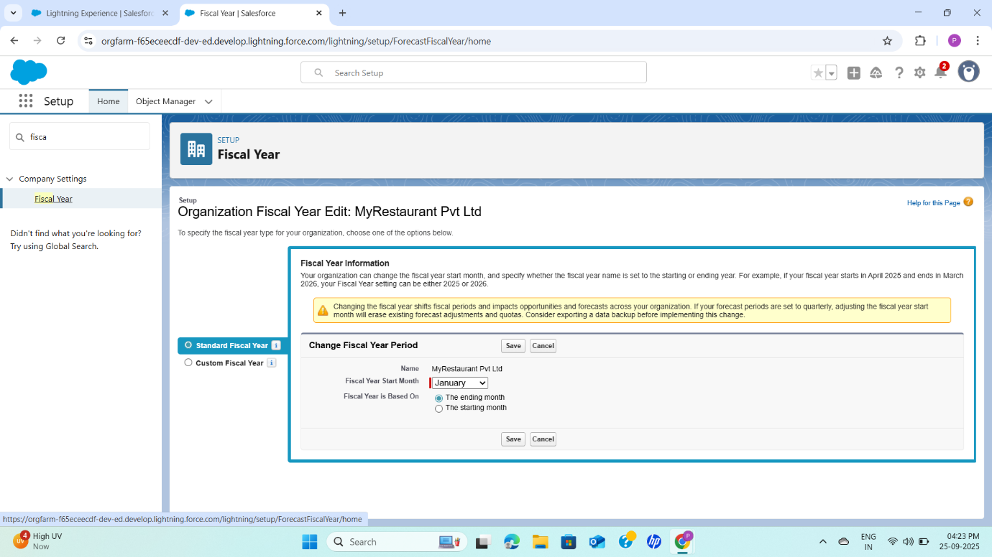

**5. Profiles**

Profiles are the backbone of Salesforce’s **security model**. They define **object permissions, field-level access, page layouts, and app visibility**.

* **Manager Profile** → Full CRUD (Create, Read, Update, Delete) on Orders, Bookings, and Loyalty objects.
* **Host Profile** → Can create and manage bookings/orders but has limited edit access.
* **Kitchen Profile** → Read-only access to orders and related order items.

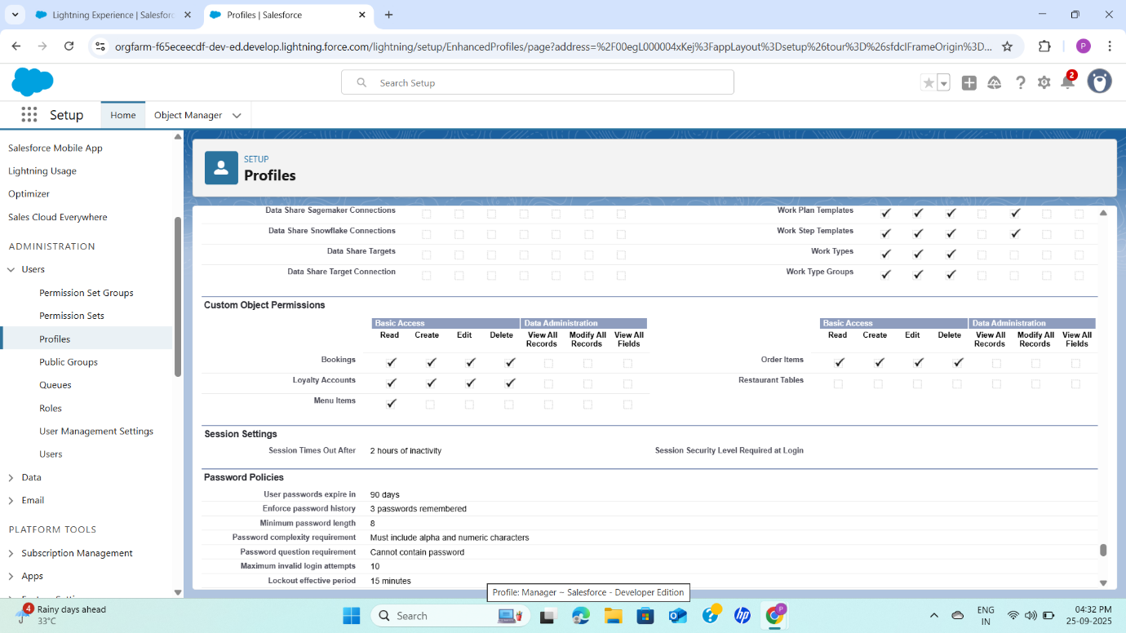

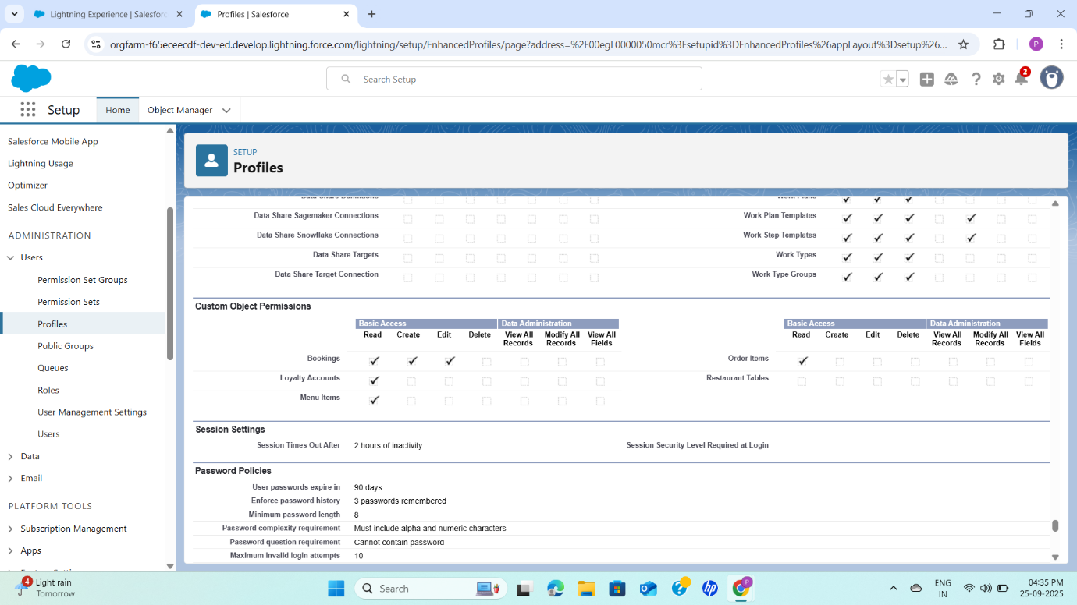

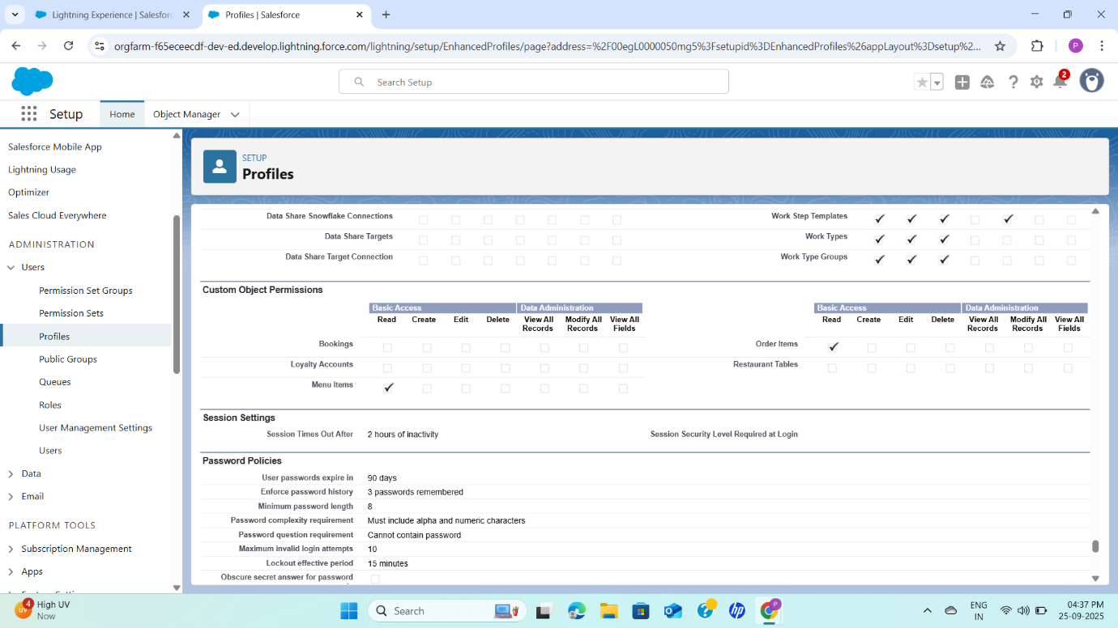

**6. Permission Sets**

Permission Sets allow granting **additional access on top of profiles** without changing the base profile.

* Example: *Order_Manager* permission set → Grants full access (Read, Create, Edit, Delete) on the Order__c object.
* Assignable to any user when temporary or extended access is required.
* This provides flexibility in managing security without cloning multiple profiles.

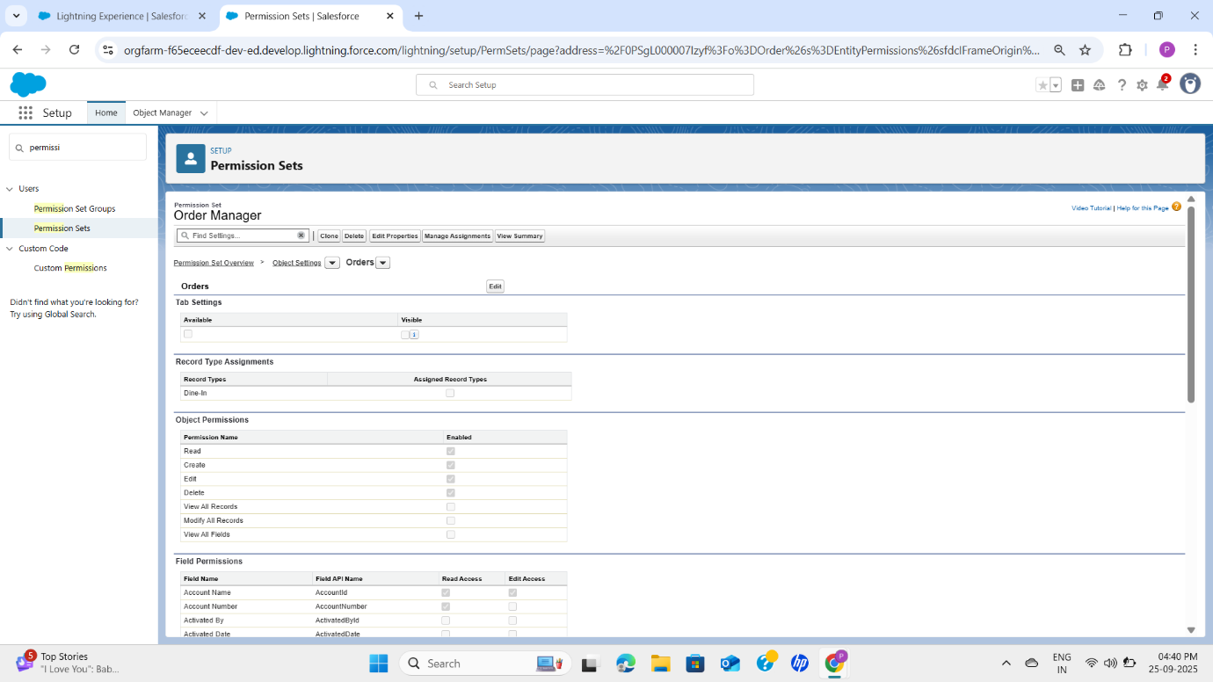

**7. Users**

Users represent real people who log in to Salesforce. Each user must be assigned a **profile** and optionally **permission sets**.

* Example: *Manager User* with Manager Profile.
* Each user consumes a license, which defines the type of functionality they can access (e.g., Sales Cloud, Service Cloud, or Platform license).

Proper user setup ensures accountability and controlled access to the system.

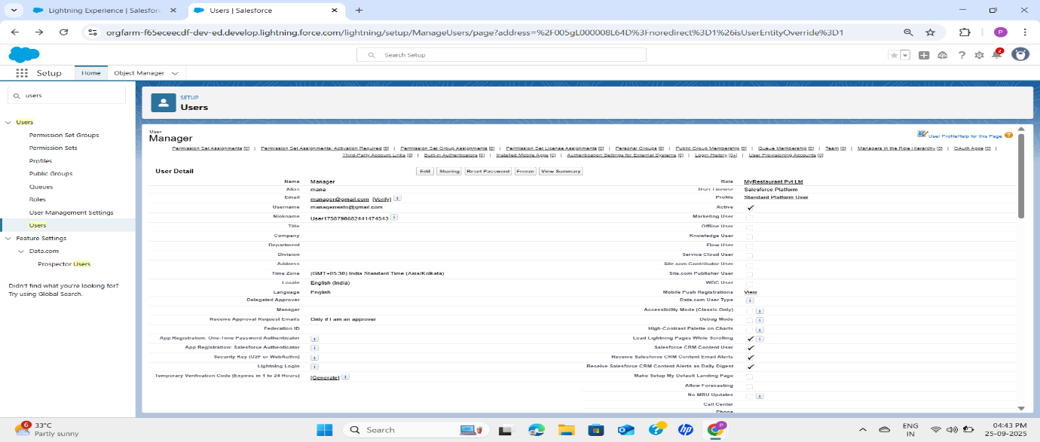

**8. Role Hierarchy**

Roles control **record visibility** and define how data rolls up in the organization.

* Top role: **Restaurant Manager** → Can view and manage all subordinate data.
* Under: **Host** → Handles bookings.
* Under: **Kitchen** → Sees order details only.

The role hierarchy supports Salesforce’s **“record sharing up the hierarchy”** rule, meaning managers can automatically see the records owned by their subordinates.

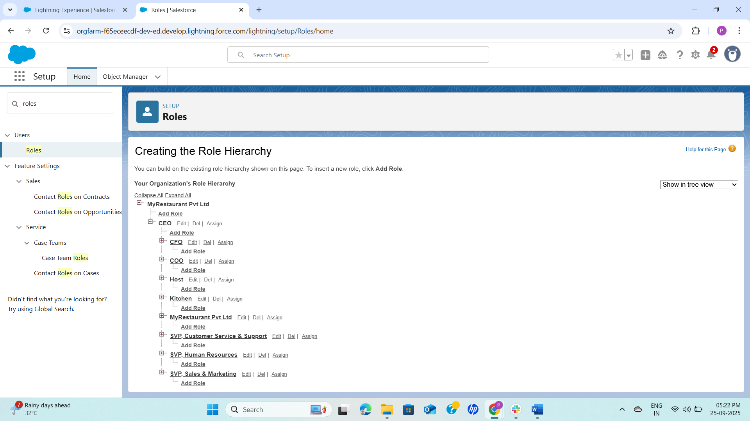

**9. Session Settings**

Session settings define the **security rules** for how long users remain logged in and how sessions are handled.

* **Force re-login after logout**: Prevents unauthorized re-entry.
* **Timeout (2 hours)**: Ensures inactive sessions automatically log out for security.
* **Lock sessions to IP address**: Optional, prevents session hijacking but may inconvenience mobile/remote workers.

This setup balances **security with usability**.

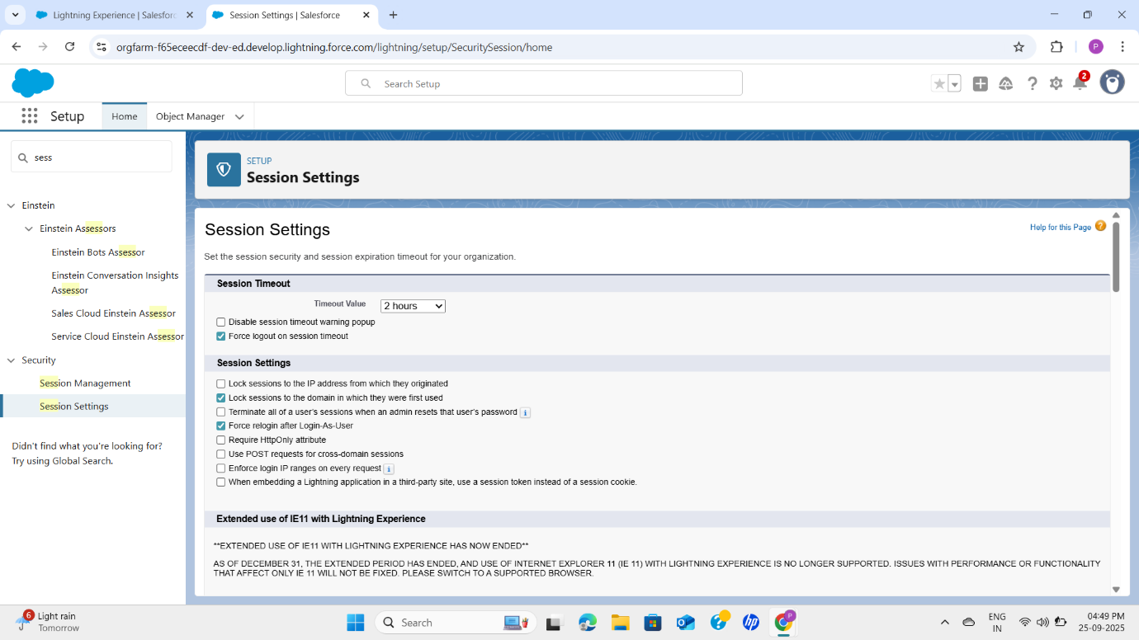

**10. Login Access Policies**

This feature allows admins to log in as other users (with permission) for **troubleshooting, testing, and training**.

* Example: The admin can log in as a Kitchen User to verify if permissions and page layouts are working correctly.
* This is critical during testing before going live.

